

CD4 COMMODITY

**USER GUIDE AND DOCUMENTATION**

**©Nacp 2014**

ADMINISTRATOR’S MODULE

The following screen shots are to guide the administrator on how to navigate through their entire module after the administrator logs into the system with the proper credentials. Once the administrator has logged in, he/she is directed to the facilities page, which will be bolded among the menu options. The other menu options are: equipment, users, change password and user guide.

On the right side there are the notification section and the side menu section. On the notification panel you will see details of devices that did not perform uploads in the past month, error statistics, and unrecognized devices that attempted to upload data. On the side menu panel there are a number of options that include:



Notifications

Side Bar

Menu Bar

# Menu bar

## Facilities

The facilities page shows a table of the facility details which contains the facility’s name, the district it belongs to, the region the facility belongs to, the partner, the equipment number, the users and actions which include; rollout and an edit option for the various facilities. This table has the ability to list various number of entries depending on what is selected the table gives the user the ability to search for a particular element on the table.

To the extreme right of the table you will find a column titled *‘Actions’.* This column in turn has two columns that give various functionalities to the user. They are:

1. Rollout

This column indicates whether the system and equipment have been rolled out or are operational in a particular facility. This column is associated with two icons as shown below. The green icon labelled (B) in the diagram below shows that that particular facility has an active implementation of the system, while the yellow icon denotes a non-active implementation of the system.

1. Edit Details

Details regarding a facility can be changed at the administrators will by clicking on the pen icon (C) found on each row.

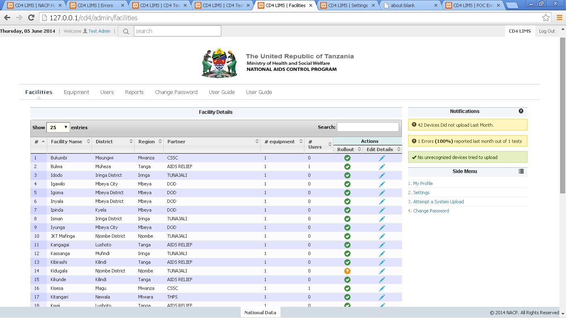

C

B

A

Search table

Number of items to list

Clicking on either of the three buttons, A,B and C will open the below pop up window.

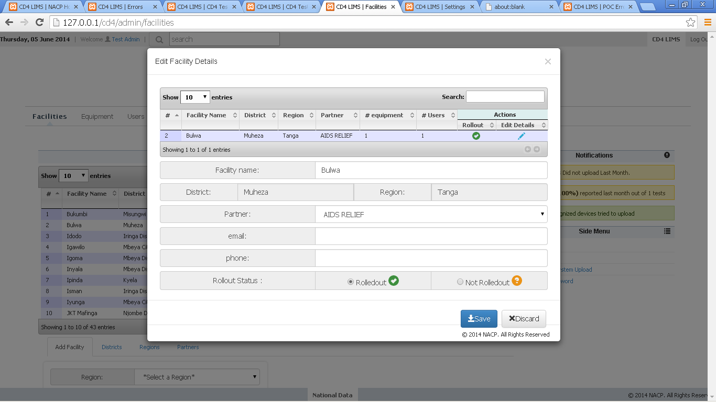

In this window the user can change the details regarding a facility except the district and region to which it belongs to. Rollout status can be changed. To close the window click on discard or on the cancel icon at the top left of the window. Save will commit the changes to the database.

Adding a facility can be done easily on this same page. The bottom of the page has several tabs.

1. Add facilities

Adding a facility will require you to complete the form under the add facilities tab and then click on save, to commit the changes

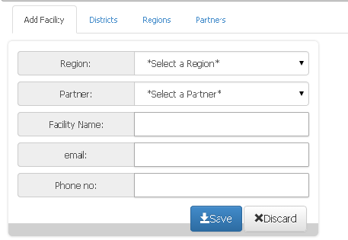

1. Regions

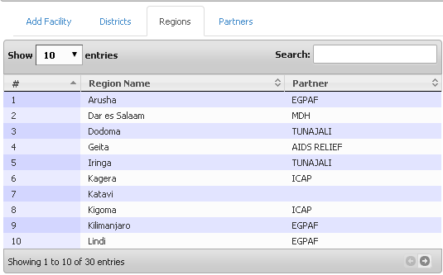

1. Districts

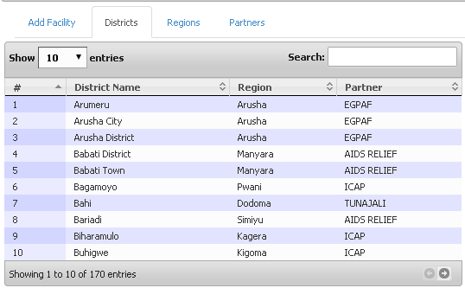

1. Partners

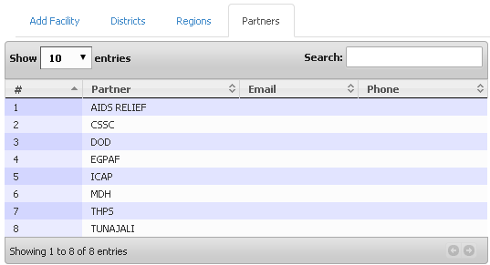

# Side Bar

Change Password

When the administrator selects the change password menu, he/she is brought to pop-up page that requires the old password, the new password that the administrator intends to be using and then retyping of the new password to ensure that the submitted password is as intended. Once the password is changed the old password becomes obsolete and would not work again unless the password is changed back to the old one.

My profile

In this section the administrator is able to edit their profile such as the: Full names, phone number and their email address. The part of the username has been made in such way that the administrator cannot edit it.

Equipment

This section shows facilities with equipment. It shows the facility to which each equipment belong to,

whether it was removed, and reason for deactivation. The status of the equipment is also shown

whether it is functional dysfunctional or obsolete. The administrator can change the status of the

equipment depending on its actual status. The last column in the table is a link that allows the

administrator to edit details about the equipment. The section on the top left allows the administrator

to view the equipments in groups of 10, 25, or 100. The user can also search for a facility using the

search section on the top right most corner of the table.

Below the equipment details table are addition tabs that enable the administrator to:

6

• Add equipment to a facility

Here the administrator assigns an equipment category to a facility then adds a serial number to

the equipment.

• Add description to equipment

In this section for every equipment category, a description is added to it.

• Add Descriptions

In this section the administrator is able to add the various categories of equipment.

7

Users

This section shows the details of the users in the system. It shows the users usernames, their names,

their phone number, their email, the type of user they are, their status, whether active, pending

activation, locked or removed. The status has a link that allows the administrator to activate, lock,

remove or put a user on pending activation when he/ she clicks on their status. The last column of the

table has a link that allows the administrator to be able to edit some of the details of the users such as

the phone number, the name and their email.

Below the user details table are tabs that enable the administrator to:

• Add users

8

• Add user types

The change password section is as described in page 2.

User Guide

In this section when the user clicks on this link, he/she will be redirected to a page that shows them a

user manual of the system. It shows how the users are able to navigate in the web application. It also

shows them the functionality of the various modules in the system.